# Migrate CM Embedded Database to a New External Database Host

Retains Postgresql

## Within Cloudera Manager

Connect to the Old CM Host admin page

Add the new host to the cluster

Stop the cluster

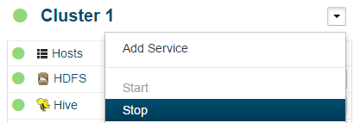

Stop all Cloudera Manager services

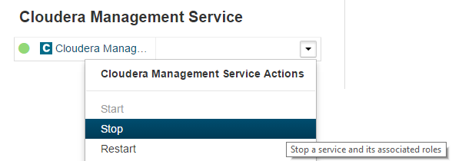

## On the Old CM Host

Login as root

service cloudera-scm-server stop

Execute the export_embedded_cm.sh script

service cloudera-scm-server-db stop

chkconfig cloudera-scm-server-db off

Copy the files from /backup to the new CM Host

## On the New CM Host

Login as root

Execute the install_cm_postgresql.sh script

Ensure the postgres user has access to the cloudera-scm-server-db.backup.xxxx.backup.gz file

su postgres

Execute the import_database.sh script with the cloudera-scm-server-db.backup.xxxx.backup.gz file as the parameter.

exit

## On the Old CM Host

Login as root

Edit the /etc/cloudera-scm-server/db.properties and /etc/cloudera-scm-server/db.mgmt.properties files and change the db.host values to the new hostname and portname

service cloudera-scm-server start

Connect to the Old CM Host admin page

## Update Cloudera Manager Database Settings

Select Cloudera Management Service-Configuration-Database

Change all Database Hostname entries to specify the new database host and port

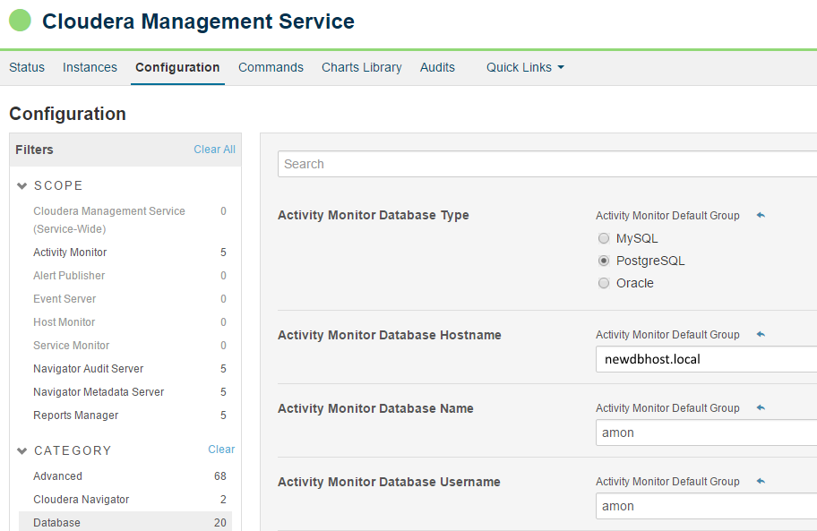

Start all Cloudera Manager services

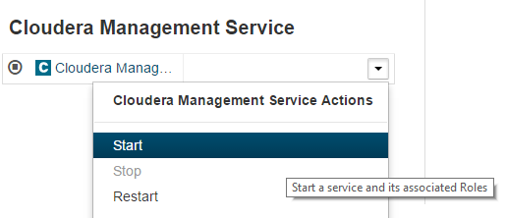

Verify Operation

## Update Cluster Database Settings

For each supported cluster select Hive, Oozie and Hue and specify the new database host and port (Configuration-Database)

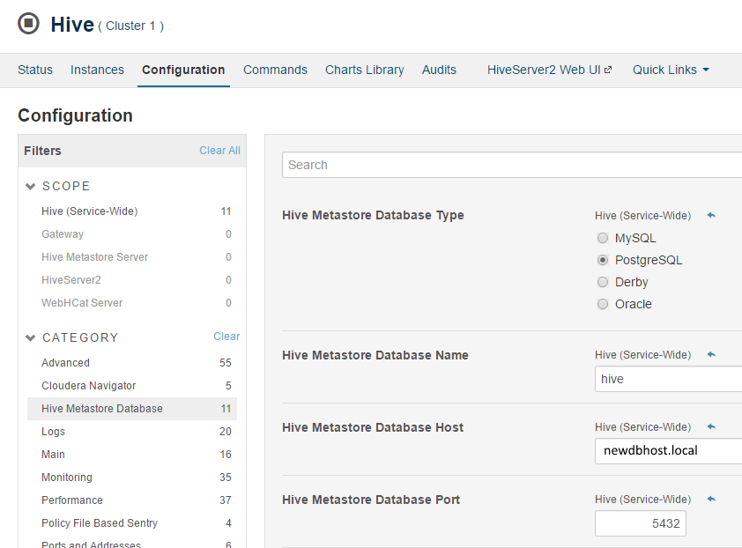

Start the cluster(s)

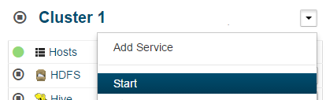

Verify Operation

# Migrate CM and Management Services to new a Host

## On the Old CM Host

Login as root

service cloudera-scm-server stop

## On the New CM Host

Login as root

yum install cloudera-manager-daemons cloudera-manager-server

tar -xf cloudera-scm-server.backup. xxxx.tar.gz -C /

Copy the /etc/cloudera-scm-server/db.properties and /etc/cloudera-scm-server/db.mgmt.properties files from the old host to the same location on the new host

service cloudera-manager-server start

tail –F /var/log/cloudera-scm-server/cloudera-scm-server.log

Make sure it starts all OK

Connect to the **New** CM Host admin page

Select the Cloudera Management Service and Delete (yep, that’s scary)

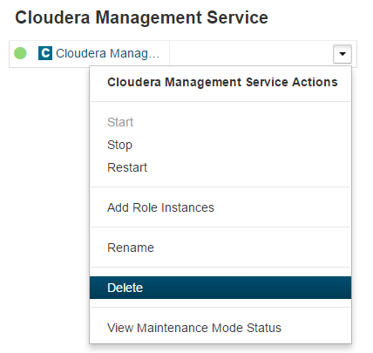

Add Cloudera Management Services, specify the database settings from the original /etc/cloudera-scm-server/db.mgmt.properties file

Note: If you are not using MapReduce (MRv1) anymore, i.e. all MR is using YARN then this is a good time to **not** add the Activity Monitor service again. Typically this is for a cluster than has been running for a while.

Start Cloudera Management Services



Start the managed clusters



## On All Hosts

Within the /etc/cloudera-scm-agent/config.ini file on each host, update the server_host property to the new hostname and service cloudera-scm-agent restart.